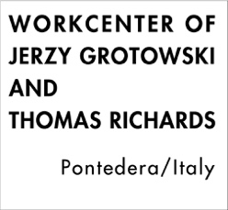 | Necessity and the Actor`s Doing Workshop conducted by Thomas Richards  Assisted by members of The Focused Research Team in Art as Vehicle  of the Workcenter of Jerzy Grotowski and Thomas Richards  Workshop Application
Personal Information
Name |  |  |  | Gender
Birth |  |  |  | Affiliation
Email |  |  |  | Phone
Level of
English Fluency
Academic Background
Portfolio
Title |  | Duration |  |  | Major Activity Content

Self Introduction
Reason for Application

Video Content
Transcription

